Project 1
Matching Game

Jessica Illescas
Professor Lehr
15 Summer CSC 5 – 46091Hybrid
7/21/15

Introduction
In my Project 1, I decided to code a game called “Matching Game” similar to a game called “Memory Game”, it was not so easy to do so. With all the given knowledge in class, I had to apply the concepts I had learn into use and code a game of my choice. Though with so little time given, since the whole course is no more than a month, I tried my best to get it done. Which I succeeded but there was still much to add.
“Memory Game” is well known for people who have played it, whether it be by having in hand a deck of cards or on a computer. That is exactly what I programmed in my game “Matching Game”. Both are games about matching cards, though in my game the cards hold certain values and must be matched to make a match pair. When all cards are all paired up, player is declared as a winner. My code prompts the player to enter a row and column in the first choice and then enter another row and column for the second choice. This choices are then compared if they are a match or not. The player is given a number of tries to see if they are able to remember and match without forgetting what the cards hold.
In “Matching Game” I originally wanted to include around 20 cards with values given as numbers (10 numbers with 5 pairs that match) and letters (10 letters with 5 pairs that match). As for the value of the cards I wanted to randomize between the letters and numbers The limit of those number would have been from 1-50 as in for the letters it would have been from A-Z (capitalize). Maybe for the next project I might add an option of difficulty, which consist of easy, medium, and hard at the beginning after the given directions, leaving the player to choose from. For an easy mode, the table will be of a small deck of cards, for instance 16 cards like I did for this project along with 3 tries given. For the medium I would either like to include more cards and no more no less of tries to challenge the player, for the hard, I include a larger deck of cards with no more no less of given tries. Once the player had exceeded the number of tries they were given or whether player had gotten all pairs matched they have the option of choosing to start over a new game or end the program itself.
Summary
In the end the amount of time I was given left me to make it simple for me to code, I successfully completed in finishing. My program consisted of more than 100 lines of code and comments. I used 4 rows and 4 columns and named each from 0-3, vertically and horizontally. I made a set of 16 cards with 8 pairs in that set. The set has values that are numbers from 1-8. Each card has been assigned a number that I chose the card to hold. When the program is ran a table consisting of rows and columns is seen along with 'X' inside the table in place of each card, so the values are hidden. For instance in row 0 and column 0, there is an X. In order to give the cards a value when chosen I assigned them a number, for instance value[0][0] = '1'. I as well give the two choices for the player to enter. In the first choice I ask them to enter the first card that they want to choose to compare with the second choice they might enter. The card value of both cards are then given and compared, if match, then they have 7 match pairs to go and if its not a match, they are given two more tries to get all 7 match pairs.
I applied the concepts I had learned in class, form the professor himself and the book, which we dealt with chapters 1-6. I applied a concept that could have been left until the next project but it made it easier for me to organize my code. The concept that I applied were a 2 dimensional array.
Description
The point of this game is to get the user to remember where a cards matching pair is located at after choosing the wrong match. It challenges them to apply what they had seen before and see if they remember the cards location with the given value.
Directions & Rules
Once the program is ran, the table made up of rows and columns appears and asks the player to enter the following. The first choice is given and prompts the user to enter the row and column they wish to compare to the second choice they enter.
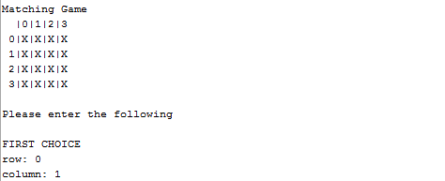

The card value of both cards are given and compared, the program will tell the user whether the cards are a match or not a match. A number of tries will be given in order to find all pairs. If all tries are exceed, it will declare “You were wrong 4 times” then in the next line it will display GAME OVER. If tries are not exceeded and cards are matched with its pair, player will be declared as winner, with the program saying “You got all 8 matching pairs” with CONGRATULATIONS, YOU WON! On the next line displayed.

Concepts
Program Composition
Location of Comments – Line 28
Execution – Line 24
Input → Process → Output – Line 73-77

Basic Programs
I/O Library – Line 10
cout, cin – 73-77
Variables type - Line 28
Global – Line 16
char - Line 28
int – Line 30

Decisions
Constructs
if – Line 89
Flowcharting
Pseudo-Code

Loops
Operator Shortcuts
increment – Line 37
Looping Constructs
do-while – Line 72
for - Line 37
Nesting – 37-43

Functions
Prototyping – Line 20
Pass by value vs. pass by reference – Line 106
Void vs. return – Line 106

Flowchart
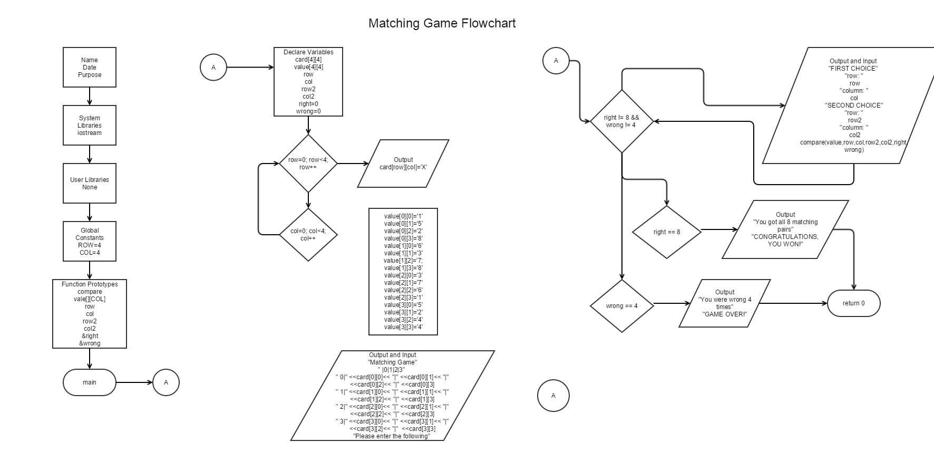
Pseudocode
/*
* File: main.cpp
* Author: Jessica Illescas
* Created on July 15, 2015, 11:25 PM
* Purpose: Matching Game
*/
// System Libraries
// I/O Library
// Namespace for iostream
// User Libraries
// Global Constants
// Function Prototypes
// Execution Begins Here
// Code Goes Here
// Declare Variables
// 2D array to hold the card 'X'
// 2D array to hold the value assigned
// When user gets pair right, starts at 0
// When user gets pair wrong, starts at 0
// Add X to card 2D array
// Compare the users choices
// User gets all pairs right
// User gets three pairs wrong
// Exit Stage Right
// Used to compare the value of the 2D array value of cards
Code
/*
* File: main.cpp
* Author: Jessica Illescas
* Created on July 15, 2015, 11:25 PM
* Purpose: Matching Game
*/

// System Libraries
#include <cstdlib>
#include <iostream> // I/O Library
using namespace std; // Namespace for iostream

// User Libraries

// Global Constants
const int ROW = 4;
const int COL = 4;

// Function Prototypes
void compare(char value[][COL], int row, int col, int row2, int col2, int &right, int &wrong);

// Execution Begins Here
int main(int argc, char** argv) {

// Code Goes Here
// Declare Variables
char card[4][4]; // 2D array to hold the card 'X'
char value[4][4]; // 2D array to hold the value assigned
int row;
int col;
int row2;
int col2;
int right = 0; // When user gets pair right, starts at 0
int wrong = 0; // When user gets pair wrong, starts at 0

for(int row=0; row<4; row++) // Add X to card 2D array
{
for(int col=0; col<4; col++)
{
card[row][col] = 'X';
}
}

value[0][0] = '1';
value[0][1] = '5';
value[0][2] = '2';
value[0][3] = '8';
value[1][0] = '6';
value[1][1] = '3';
value[1][2] = '7';
value[1][3] = '8';
value[2][0] = '3';
value[2][1] = '7';
value[2][2] = '6';
value[2][3] = '1';
value[3][0] = '5';
value[3][1] = '2';
value[3][2] = '4';
value[3][3] = '4';

cout << "Matching Game" << endl;
cout << " |0|1|2|3" << endl;
cout << " 0|" <<card[0][0]<< "|" <<card[0][1]<< "|" <<card[0][2]<< "|" <<card[0][3]<< endl;
cout << " 1|" <<card[1][0]<< "|" <<card[1][1]<< "|" <<card[1][2]<< "|" <<card[1][3]<< endl;
cout << " 2|" <<card[2][0]<< "|" <<card[2][1]<< "|" <<card[2][2]<< "|" <<card[2][3]<< endl;
cout << " 3|" <<card[3][0]<< "|" <<card[3][1]<< "|" <<card[3][2]<< "|" <<card[3][3]<< endl;
cout << " " << endl;
cout << "Please enter the following" << endl;
cout << " " << endl;

do{
cout << "FIRST CHOICE" << endl;
cout << "row: ";
cin >> row;
cout << "column: ";
cin >> col;

cout << "SECOND CHOICE" << endl;
cout << "row: ";
cin >> row2;
cout << "column: ";
cin >> col2;
cout << " " << endl;

compare(value,row,col,row2,col2,right, wrong); // Compare the users choices
}while(right != 8 && wrong != 3);

if(right == 8) // User gets all pairs right
{
cout << "You got all 8 matching pairs" << endl;
cout << "CONGRATULATIONS, YOU WON!" << endl;
}

if(wrong == 3) // User gets three pairs wrong
{
cout << "You were wrong 3 times" << endl;
cout << "GAME OVER" << endl;
}

// Exit Stage Right
return 0;
}

// Used to compare the value of the 2D array value of cards
void compare(char value[][COL], int row, int col, int row2, int col2, int &right, int &wrong)
{
cout << "Card 1 value: " <<value[row][col]<< endl;
cout << "Card 2 value: " <<value[row2][col2]<< endl;

if (value[row][col] == value[row2][col2])
{
cout << "MATCH!" << endl;
right++;
cout << "# of right times: " << right << endl << endl;
}

else if (value[row][col]!= value[row2][col2])
{
cout << "This is not a match, TRY AGAIN" << endl;
wrong++;
cout << "# of wrong times: " << wrong << endl << endl;
}
}

